**FAMU-FSU College of Engineering   
Department of Electrical and Computer Engineering**

**PROPOSAL**

**EEL4911C – ECE Senior Design Project I**

Project title: **SAE Formula Electric Racer**

Team #: 3

Student team members:

-Tomas Bacci, Mechanical Engineering (Email: [teb08@fsu.edu](mailto:teb08@fsu.edu))

- Danny Covyeau, Electrical Engineering (Email: [dc08k@fsu.edu](mailto:dc08k@fsu.edu))

-Scott Hill, Electrical Engineering (Email: [sbh09d@fsu.edu](mailto:sbh09d@fsu.edu))

-Stephen Kempinski, Mechanical Engineering (Email: [smk09f@fsu.edu](mailto:smk09f@fsu.edu))

-George Nimick, Mechanical Engineering (Email: [gan07@fsu.edu](mailto:gan07@fsu.edu))

-Sam Risberg, Mechanical Engineering (Email: [sjr07c@fsu.edu](mailto:sjr07c@fsu.edu))

Senior Design Project Instructor: **Dr. Michael Frank**

**Dr. Hui Li**

**Dr. Patrick Hollis**

**Dr. Chiang Shih**

Submitted in partial fulfillment of the requirements for

EEL4911C – ECE Senior Design Project I

October 20, 2011

**Project Executive Summary**

**Table of Contents for Project Proposal**

Table of Contents.

Project Executive Summary 2

1. Introduction 4

**1.1** **Acknowledgements** 4

**1.2** **Problem Statement** 4

**1.3** **Operating Environment** 4

**1.4** **Intended Uses and Users** 4

**1.5** **Assumptions and Limitations** 4

**1.6** **Expected End Product and Other Deliverables** 4

2. Proposed Design 5

**2.1** **Overview** 5

**2.2** **Propulsion** 9

**2.3** **Accumulator** 9

**2.4** **Motor Control System** 9

**2.5** **Braking System** 9

**2.6** **Chassis** 10

**2.7** **Steering** 10

**2.8** **Suspension** 10

**2.9** **Charging System** 10

3. Statement of Work 10

# Appendix A located at end of document1. Introduction

* 1. **Acknowledgements**
  2. **Problem Statement**

A student conceived, single driver, formula all electric racecar is to be designed and fabricated with the intent of competing with it in the 2012 Formula Hybrid competition. The design’s toughest challenge will be to make sure it abides by all competition rules. These rules place many restrictions on areas like chassis designs, braking systems, and accumulator size that must be carefully considered. The vehicle will be designed as a prototype of a compact, agile car that should appeal the average non-professional weekend autocross competitor. Since it is competing under the all-electric category the vehicle will use batteries as its energy source (no ICE). The car must be safe to operate and be equipped with multiple emergency features

* 1. **Operating Environment**

The operation environment that the team will design for will be a flat racing track or drag strip such as the New Hampshire Motor Speedway where the competition will take place. The vehicle will be driven and tested out in parking lots prior to competition for tuning purposes, but the main goal will be for it to complete the acceleration and endurance events at competition grounds. The vehicle needs to be water-resistant enough to operate during rainy conditions as well. Safety is a major concern since the vehicle will be competing in a racing environment where a crash is always possible.

* 1. **Intended Uses and Users**

The vehicle is meant to be designed for the non-professional weekend autocross competitor. However, the main intended users for our specific prototype will be team members as well as any competition representatives. The vehicle must be designed to accommodate drivers from the 95th percentile of men (max) to the 5th percentile of women (min). For team members to be able to race at competition they will need to provide a valid driver’s license, provide proof of insurance, and be capable of handling and controlling the vehicle at high speeds. Additionally anyone driving the car will be wearing protective equipment (suit, helmet, gloves).The vehicle will be used to compete at the 2012 Formula Hybrid competition under the all-electric category.

* 1. **Assumptions and Limitations**

**Assumptions:** The following assumptions were made by the design team in regard to the project. The vehicle is being designed to compete in a closed track environment, therefore it will be optimized for flat solid surfaces and not hilly or off-road courses. The team will have some vehicle parts and materials donated to them, and they will function correctly. The car is being designed for daytime use as the group will not focus on components such as lights or reflective panels for night time visibility. The team entire team will travel to Loudon, New Hampshire for the competition event in late April.

**Limitations:** The major limitations of this project are embedded in the 2012 competition rules. One of these is a limit on the accumulator system of 5,400 Wh or max price of $7,200. The vehicle must complete a 75 meter stretch in less than 10 seconds as a minimum completion requirement. The roll hoops on the chassis must be made from one continuous tube (no welds). The car needs to be able to seat people from the 95th percentile of men to the 5th percentile of women. The braking system must apply force to every wheel and successfully stop the vehicle without locking them up. The suspension system must keep the vehicle with at least an inch of clearance with the road, and must provide the wheels with at least 2 inches of wheel travel. With the exception of minor tuning and aesthetic features, the project must be completed by mid April as the competition begins on April 30th 2012. The project must be funded and completed with the allotted budget.

* 1. **Expected End Product and Other Deliverables**

The end product will be an all electric, compact, single driver vehicle that is agile and fun to drive. The vehicle will be energy efficient and be able to participate competitively in local race tracks. The batteries will be included with the vehicle and will be recharged on board, from any standard household outlet.

# 2. Proposed Design

* 1. **Overview**

The design being proposed is that for a competition being hosted by the Society of Automotive Engineers under the Formula Hybrid Student Design Competition. It was agreed upon to design for the fully electric category and, thus, the component break down will reflect this decision. Although the vehicle will be fully electric, there will be several mechanical components, as well as electrical ones. Mechanical systems on this vehicle will include systems such as braking, suspension, chassis, steering and powertrain. The electrical systems will include the electric motors for each wheel, the controllers and their subcomponents, as well as a battery management system.

This design is a vision of the end product that this team feels is tangible in terms of design, feasibility and monetarily, using our proposed budget. However, this will be contingent upon the amount of funds that will be allotted to us and will change our design accordingly. For instance, a reduced budget may change the vehicle by only monetarily permitting a two wheel drive vehicle, whereas increasing our monetary allotment would permit us to purchase better struts or other components that would assist in increasing our overall performance.

The budget is only one of many constraints placed on the vehicle. The majority of the constraints will be a result of the rules we must follow in order to participate in the competition. Although these rules lead many of the design systems in a particular direction, there is still enough freedom to develop a unique and effective design. One of the goals, however, is to improve upon the design from the past two years. This may involve optimizing the existing design or a complete redesign. Below are the two top level designs that illustrate the required components to make the vehicle function, as currently envisioned by our group of two electrical engineering students and four mechanical engineering students. Figure 1 is the top level design for the mechanical aspect and Figure 2 illustrates the top level design for the electrical system.

Figure : Mechanical Top Level Design

Throttle Control

Brake Pedal

Brake Fluid Reservoir

Brake Master Cylinder

Steering Rack & Pinion

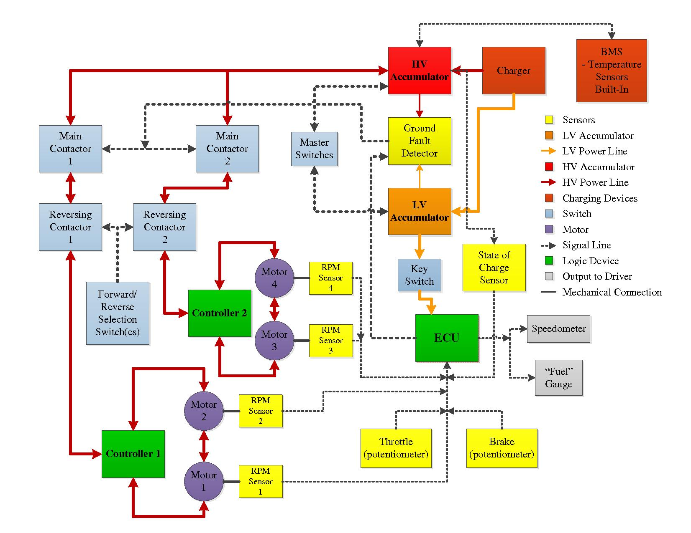Figure : Electrical Top Level Design

The suspension design will be similar to Figure 3 shown below. Its components will consist primarily of the damper and spring, a push-pull rod, the control arms (or A-arms), and the upright (or knuckle). Basically the upward movement of the wheel/control arms will be transferred via the push-pull rod to the spring/damper assembly which will help the tires to maintain contact while the vehicle goes through a turn or over an obstacle.

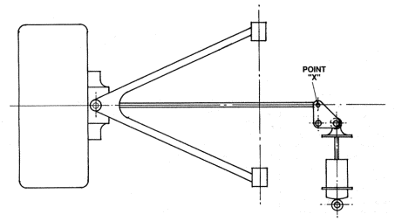

Figure : Typical push-pull rod suspension for SAE Formula

The chassis for this year will be redesigned and constructed from the same material, 4130 Chromoly Steel. This is an aircraft grade steel that is considerably stronger than typical 1018 steel. This was chosen because of its high strength without having to sacrifice the addition of a significant amount of weight and for the ease of which this can be built. A few of the team members have experience constructing a chassis in this manner and therefore the design will be able to simplify the build process and enable the production to occur in a timely manner so that testing can begin as soon as possible. Below, in Figure 4, is a preliminary design of what it should look like.

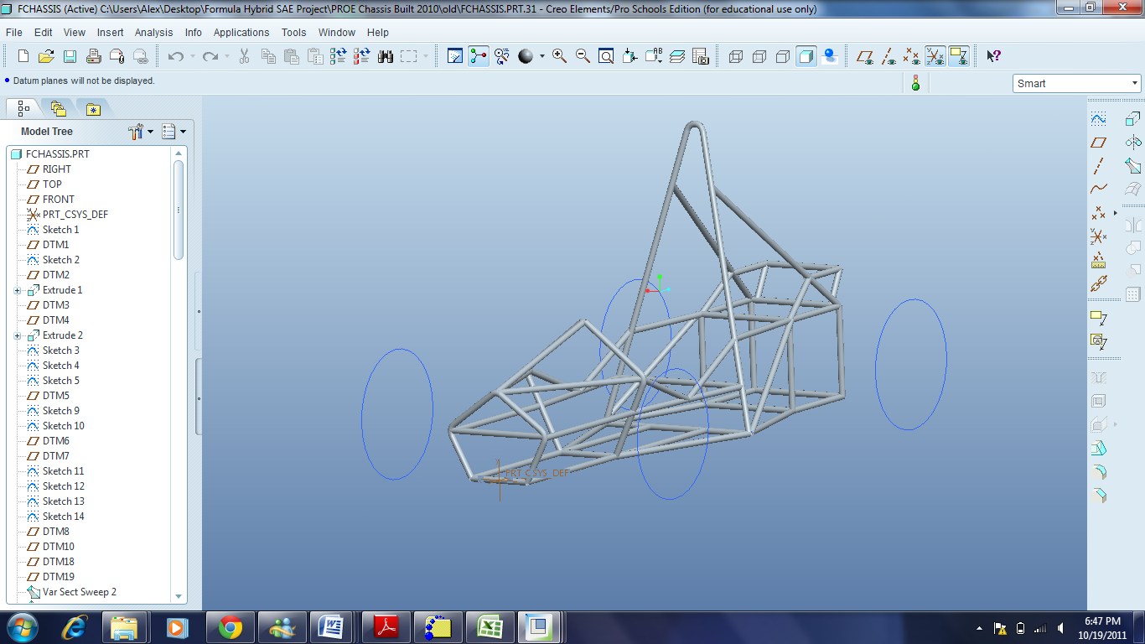

Figure : Preliminary Model of Chassis

As with any vehicle, this car must be capable of stopping. In fact, as constrained by the rules, the vehicle must lock all four wheels and have two separate hydraulic systems as a failsafe in case a leak develops, so that at least two wheels are capable of locking. The basic components that will be incorporated in this system are a master cylinder with a brake fluid reservoir, a foot pedal, the brake calipers and brake discs, and the brake lines that will deliver the fluid to the calipers.

The steering system will comprise of a basic rack and pinion set. Essentially, what this system will do is convert the rotational motion of the steering wheel into a translational motion that will move the front tires at the same time to allow the vehicle to maneuver around turns and obstacles. These components will consist of a steering wheel, a steering column, the rack and pinion, and tie rods.

For the electrical aspects of the car one of the most important systems is battery system and is comprised of batteries, a battery management system, capacitors, and a charging system. The other main system on the vehicle is the electric drive system that is compromised of the motors on the vehicle and the motor controllers. These two systems will be heavily integrated since they are dependent on each other. The other parts of the electrical system are shown in the top level diagram in Figure 2. These parts consist of a Ground Fault Detector (GFD); various contactors that control the direction the motors move the car in (i.e. forwards and backwards), RPM sensors for the motors, other sensors and an Electrical Control Unit (ECU) that will take in the readings from all of the sensors and make decisions about how things should be adjusted in the electrical system in real time while the car is running.

* 1. **Propulsion**

The vehicle will take advantage of four electric motors to propel itself, one on each wheel. These will be mounted onboard the vehicle (i.e. not ‘in-wheel’ or ‘hub’ motors) allowing the unsprung weight of the wheels to be as little as possible. Each motor will have its own gear reduction so as to limit the top speed of the vehicle as well as increase the mechanical torque.

The two front motors will have a single controller and the two rear motors will have their own separate controller. The front controller will be fed from a battery bank in the front while the rear battery bank will be fed from a separate battery bank in the rear. This will help distribute the weight evenly between the front and rear of the vehicle. The two front motors will be wired in a series configuration so as to only require a single controller. The same will be done in the rear. The controllers will also have a regenerative braking feature built in that will be able to take advantage of the momentum of the vehicle from all four electric motors in the configuration described above.

* 1. **Accumulator**

The accumulator system will be comprised of batteries, capacitors and a Battery Management System (BMS). The batteries will be connected to the BMS which will monitor the rate of charge and discharge of the batteries. The batteries and capacitors will then be connected to the motor controller in order to power the electric drive of the vehicle.

The battery that is the prime candidate at the moment is a type of lithium polymer battery. Further justification will be done but these batteries seem to have the highest specific energy per gram. These batteries are also relatively easy to purchase and connect to the system compared to other types of batteries that need to have each individual cell connected together in a special way. One possible battery configuration is shown on the next page in Figure 5.

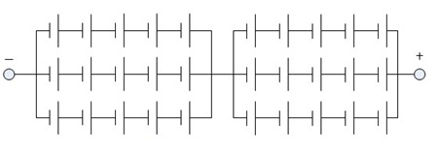

Figure : Battery Configuration

* 1. **Motor Control System**

The motor control system will consist of two permanent magnet motor controllers. One will control the front motors while the other will control the rear motors. The motors in the front/back will be connected in a series configuration such that a single controller can operate both motors simultaneously. This will not only simplify the design but will also create somewhat of a differential-like effect for the front and rear. If one of the front (or rear) two motors were to lose traction, its impedance would increase while the motor it’s connected in series with would maintain a lower impedance. Due to this characteristic the motor that is not slipping would receive more power. In other words, if a wheel starts to slip, the wheel directly across from it (that is getting better traction) will automatically receive more power. As mentioned in the Propulsion section above, the controllers will have their own separate battery packs, one in the front and one in the rear to help create a better weight balance between the front and rear. The controllers will also have regenerative braking built into them. As a potentiometer connected to the brake pedal changes resistance (by applying a variable force to the brake pedal) this will cause more and more energy to be recaptured from the motors (due to the momentum of the vehicle) and stored back in the battery packs.

* 1. **Braking System**

The implementation of the braking system will have one main goal safety. Coming to a complete stop as well as proper brake performance falls under general safety for any automobile. After we have calculated the total weight of the car we will choose brake that will compliment this weight distribution in an emergency braking situation.

The FSAE Hybrid rules declare that a braking system should be able to lock up all four wheels. This should be a simple task with a rotor and caliper setup with proper brake line pressure. There will be a brake over travel switch that will ensure the engine will shut down in the case of lost brake pressure. The main components of the system are rotor, caliper, brake lines, master cylinder, fluid reservoir and brake pedal.

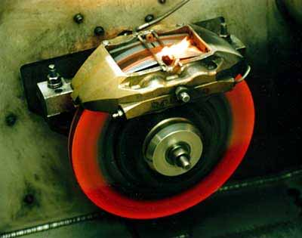

Figure : Brake Disc and Rotor

* 1. **Chassis**

The chassis will be made of tubular frame rails as well as steel tubing that is compliant to the 2012 FSAE chassis limitations. The chassis will need to house the driver, suspension, batteries and every other component of the car. Because of this the chassis will need to be designed to handle the weight of the driver as well as the structural support to handle all of the components.

* 1. **Steering**

The steering system is basically a network of components that work together to control the direction of the vehicle. For this vehicle, the steering system must be mechanically connected to the front wheels, according to the rules, and therefore, is a mechanical system of this vehicle. The steering should function by moving both wheels in the same direction when the steering wheel is turn. Many different setups could be considered, in terms of both steering components and types of steering designs, such as Ackermann steering geometry.

* 1. **Suspension**

The suspension system will connect the vehicle’s sprung and unsprung weight (wheels to chassis) and allow the driver to maintain traction and stability during turns and stops. The suspension geometry will feature a multi-link independent set up for each wheel. Both the front and real will feature double A arms (4 links), the only difference being the fifth link. The front will attach to a steering link, where the rear will have an extra toe-control link. Each wheel will have one degree of freedom in the vertical direction (jounce, rebound) by restricting the others with the five- link connection.

* 1. **Charging System**

The charging system of the vehicle will use a type of lithium ion battery management system. This system will measure the State of Charge (SOC) of the battery packs and adjust the discharge or charge rate of the batteries as needed in order to make sure that no damage occurs to the batteries. This system will also measure the temperature of the batteries to make sure that they are not getting to hot. If these batteries were to get above a certain temperature then they could possibly catch on fire or explode because of their high volatility so they will be closely monitored during at least the first two charging cycles to make sure no such damage will occur.

**3. Statement of Work**

**3.1 Task 1: Project Management**

Since the vehicle is inherently split between mechanical and electrical systems, the electrical engineering students will be in charge of the electrical portion while the mechanical engineering students will be in charge of their respective portion. The electrical students are in charge of designing the motor design and setup, as well as the battery management system. The mechanical students will be in charge of designing the chassis, the suspension, the braking system, and the steering system. Each system will have subcomponents that will need designing as well. This means that either parts need to be purchased and assembled to fit the designed system or it could mean the parts may need to be designed and fabricated to perform the same goal of meeting the overall design needs.

George Nimick, as the project manager, will be in charge of overseeing the project’s progress and making sure that the overall goal for the vehicle is being considered within each system of the vehicle so that the components will be able to come together and function as envisioned. Each system of the vehicle, however, will have its own manager. Scott Hill will be in charge of the overall electrical system, while George Nimick will also be in charge of the mechanical system. One of the largest tasks that will be performed by these two is ensuring the compatibility of the electrical and mechanical systems.

For the electrical system, there will be two major systems. Scott Hill will in charge of the battery management system, which will also involve the selection and wiring of the energy accumulators. Danny Covyeau will be in charge of the motor design. This will involve close work with Scott but will focus more on the motor selection and its wiring and control.

The mechanical system will consist of four primary systems. Stephen Kempinski and Tomas Bacci will be in charge of the suspension design, which will consist of selecting suspension characteristics, as well as, assisting to choose mounting points on the chassis. Because of its close relation to suspension, the steering system will also be designed by Stephen and Tomas. This will entail choosing a way to integrate the steering with while allowing two motors to drive the front wheels as well since the vehicle will be designed for all-wheel drive. The chassis will be designed by George Nimick and Sam Risberg. They will be in charge of designing a structurally sound shell that will protect the driver and the components within it, while comfortably and efficiently accommodating the driver and all of the components that is houses. This also means that a structural finite element analysis will be performed. They will also be in charge of the braking system and ensuring that the components are properly chosen so that the vehicle can effectively come to a complete stop and be able to simply slow down depending on the situation at hand.

**3.2 Task 2: Electric Drive**

**3.2.1 Objective**

The electric motors must work with one another in such a way to safely, efficiently and quickly propel the vehicle. The motors should all be the same make and model to simplify the design.

**3.2.2 Approach**

A battery bank located at each end of the vehicle will provide power to the motor controller on that end of the vehicle. The controller will then take signals generated by the ECU and the brake pedal and convert them into throttle control and regenerative braking respectively. The accelerator pedal (potentiometer) will be connected as an analog input to the ECU where it will then be split into two separate (and possibly different) analog outputs based on several ECU sensor readings (i.e. RPMs of each motor, Forward/Reverse selector switch, etc.). The two output signals will be based on an algorithm programmed into the ECU. One will go to the front motor controller and the other will go to the rear motor controller. The motor controllers will then convert this signal into an output that will power the motors.

**3.2.2.1 Motor Controller/Motor Control System**

**3.2.2.1.1 Objective**

The motor controllers should be able to control two motors in series simultaneously as well as have a regenerative braking feature to recapture electrical energy from the motors when the vehicle is decelerated.

**3.2.2.1.2 Approach**

The motor controller selected should be specifically built for the type of motor chosen (i.e. ac induction, series dc, etc). It should be able to handle at least twice the rated voltage of the motor and the same maximum current of the motor. It must also have regenerative braking built-in to allow energy to be recaptured from each motor.

**3.2.2.1.2.1 Throttle Control**

**3.2.2.1.2.1.1 Objective**

The throttle should directly affect the vehicles speed and/or torque.

**3.2.2.1.2.1.2 Approach**

The throttle will consist of an accelerator pedal called a pot or potentiometer box. This device will send an analog signal directly proportional to the angle it is being pushed at to the ECU. The ECU will then plug this signal, along with signals from each motors RPM sensor, the brake pedal, and other sensors into an algorithm that will determine what analog values to send to both the front and rear motor controllers.

**3.2.2.1.2.1.3 Test/Verification Plan**

The potentiometer will initially be tested by applying a low voltage source (~ 5VDC) across its terminals and then a voltmeter will be used to measure the voltage created between the wiper and ground. Several values will be recorded to make sure that the potentiometer uses a linear scale and not logarithmic or exponential. Upon creating the ECU system, the two outputs from the ECU to the motor controllers will then be measured to make sure they are within a given range. The vehicle will need to be tested repeatedly to make sure that the ECU algorithm for controlling the motors is satisfactory

**3.2.2.1.2.1.4 Outcome of the Task**

After testing the pot box it will be connected to the ECU. The ECU will then be programmed with a motor control algorithm. This algorithm will be tested prior to wiring the ECU to the motor controllers by simulating sensors inputs to the ECU and measuring the two resultant output control signals. Analog signals can be simulated using variable DC power supplies while sensors such as the RPM sensors (encoders) on the motors can typically be simulated using a function generator. Upon determining that the output control signals behave properly, the ECU will be wired to the motor controllers and the system will be tested by actually driving the vehicle. The algorithm will be tweaked as necessary to give the desired driving characteristics preferred by the drivers.

**3.2.2.2 Electric Motors**

**3.2.2.2.1 Objective**

The objective here is to measure the current through the motor as well as the output power before connecting the motor to the vehicle.

**3.2.2.2.2 Approach**

The motor will be mounted to a small dynamo (possibly at the Center for Advanced Power Systems). The current will be measured as the input current to the motor from the controller.

**3.2.2.2.1.1 Gearbox and driveshaft**

**3.2.2.2.1.1.1 Objective**

The gear box will limit top end speed and maximize the acceleration and torque of the vehicle. The output of the gearbox will transfer power to the wheels with the use of driveshaft.

**3.2.2.2.1.1.2 Approach**

A gear reduction will be calculated given the input of the motor with the output weight of the driveshaft. The drive shaft should be light weight but also capable of withstanding forces of torque from the output of the gearbox and resistance contact patch forces.

**3.2.2.2.1.1.3 Test/Verification Plan**

CAD modeling of the gear reduction can be made to verify correct output to the driveshaft for the entire range of the electric motor input. Simple modifications to gear ratios can be made to determine the best toque and acceleration curves.

**3.2.2.2.1.1.4 Outcomes of Task**

The team will have a gear ratio for the gearbox that will perform well at all desired speeds that will be expected of the vehicle at competition. The team can advance to purchase the four gears sets and driveshafts as well as fabricate the four gearbox housings.

**3.2.2.2.3 Test/Verification Plan**

A computer will be used to plot the current vs RPM and mechanical power vs rpm. This information will be saved for later reference.

**3.2.2.2.4 Outcomes of Task**

Upon completing testing the motor, this data will be compared with data provided by the manufacturer and gear ratios and motor control algorithms will be adjusted accordingly.

**3.3 Task 3: Accumulator**

**3.3.1 Objective**

The objective of the accumulator is to power the electric motors that propel the vehicle.

Characteristics of this accumulator are to be robust, compact and lightweight. These accumulators must not exceed $7,200 in cost and must not exceed 5,400 Wh in Capacity.

**3.3.2 Approach**

The accumulator system will be comprised of batteries and capacitors connected to the motor controller to power the vehicle’s electric drive.

**3.3.2.1 Acquire Batteries**

**3.3.2.1.1 Objective**

The batteries must provide a voltage that is high enough to power to at least two motors in series at 74V a piece. These batteries must also have the required capacity to propel the vehicle through all three of the events at the competition: Acceleration, Endurance and Motocross

**3.3.2.1.2 Approach**

To acquire these batteries the World Wide Web will be used. There are many good websites that sell the types of batteries being considered for use in the electric vehicle. These websites list all of the required data for the use of the batteries such as: voltage, discharge rate, dimensions of the battery casing, pricing and many others. Once this data has been complied a decision on what type of battery will be used in the car.

**3.3.2.1.3 Test/Verification Plan**

Once the batteries arrive each will be tested to ensure that they have the appropriate voltage, current and capacity specified by the vendor. All batteries will be charged to maximum capacity but special considerations will be made to monitor the temperature and voltage to make sure that the batteries will not be damaged in any way. The batteries will then be discharged to a safe depth that will not affect the life of the battery. During this testing the values measured will be recorded in a table for future reference. Batteries will be individually numbered so that they can be easily referred to in the table.

**3.3.2.1.4 Outcome of Task**

By completing this task the team will have data on each battery that will correspond to the number on the battery. If any of the batteries are found to be defective the vendor will be contacted to receive a replacement.

**3.3.2.2 Abuse Test**

**3.3.2.2.1 Objective**

The abuse test will used to make sure that the batteries can handle the continuous current and burst current that the vendor specifies prior to the time of purchase.

**3.3.2.2.2 Approach**

For the abuse test a single battery pack at a time (with a total of 2 or 3) will be connected to a resistive load that should produce the desired current in each test. Since the required current is very high (hundreds of amps) a load with a high power rating and low resistance will be required. The best way to achieve this will be to use multiple resistive elements wired in parallel.

**3.3.2.2.3 Test/Verification Plan**

The two tests that will be performed are continuous and 10 second burst. Two batteries are being used to verify that the batteries are consistent in their characteristics. If either battery fails a test the discharge rate will be reduced by about 5C and the test will be conducted again. If the reduced discharged rate does not fix the problem then the manufacturer of the batteries will be contacted and asked for replacement batteries.

**3.3.2.2.4 Outcome of Task**

This task will verify that when the batteries are installed in the vehicle that they will work as intended and propel the vehicle at the desired speeds. Since testing every single battery would be harmful the batteries performance, all batteries will be assumed to be working if the two tested batteries work as intended unless something happens to suggest otherwise.

**3.3.2.3 Accumulator Enclosure**

**3.3.2.3.1 Objective**

The accumulator enclosure must be able to be sturdy and able to withstand forces listed in Appendix A. The enclosure must also be fireproof and provide insulation between live electrical parts.

**3.3.2.3.2 Approach**

Because the competition rules state that the battery enclosures must be easily inspected, a clear polycarbonate insulating material will be used to construct the accumulator enclosure. Since the chassis design is not complete yet the material can be formed in many different shapes to fit the chassis and still hold the required batteries.

**3.3.2.3.3 Test/Verification Plan**

In order to test that the enclosure can withstand the required forces during driving on a course the enclosure will be strapped down in the back of a truck and similar motions will be performed. The enclosure will also be immersed in water while empty in order to make sure it is air tight. Once these tests have been completed the enclosure will be tested for its dielectric strength as well to make sure it can withstand the required voltages.

**3.3.2.3.4 Outcome of Task**

By completing this task the team will be sure that they can pass the 60 second water spray test if required at competition and pass other safety requirements involving insulation of the enclosure. The team will also be sure that batteries will not come lose inside the enclosure.

**3.3.2.4 Battery Packaging and Wiring**

**3.3.2.4.1 Objective**

The batteries must be packaged in a way that they are properly insulated and be allowed to distribute heat so that the batteries will not overheat. The batteries must also be wired in such a way that a practical voltage and the proper capacity can be attained.

**3.3.2.4.2 Approach**

For the insulation of the batteries the same material used to build the accumulator casing will be used to create individual compartments for the batteries. For cooling of the batteries fans will be placed in the enclosure to create airflow for cooling purposes. For the wiring of the batteries a combination of series strings of batteries will be connected in parallel. Then these parallel strings can be connected in series to attain the desired voltage. This makes the batteries easier to fuse and allows the proper voltage while still allowing the system to have enough capacity to power the car for the desired amount of time.

**3.3.2.4.3 Test/Verification Plan**

The dielectric strength of the insulating materials will already have been tested in the accumulator enclosure task. In order to test the wiring of the batteries voltage and current measurements will be taken to verify that the wiring configuration is working correctly.

**3.3.2.4.4 Outcome of Task**

This task will ensure that the correct voltage and current will be produced by the accumulator**.**

**3.3.2.5 Capacitors System**

**3.3.2.5.1 Objective**

If time permits then the team will use a bank of capacitors in combination with the battery system to be used with regenerative braking and times of fast acceleration. These capacitors must be able to recover energy from the regenerative braking system and be allowed to discharge when the motor controller requests the energy.

**3.3.2.5.2 Approach**

For this system to be created a bank of capacitors with the required capacity and voltage ratings will be connected in such a way that they can send and receive energy from the motor controller while not affecting the battery systems stability or the motor’s performance.

**3.3.2.5.3 Test/Verification Plan**

In order to test the capacitor bank they will be charged to a certain level of full capacity and connected to a load so that the discharge characteristics can be measured. Once these have been tuned to their specifications they will be connected to the battery system through the motor controller and tested to make sure that everything is working properly

**3.3.2.5.4 Outcome of Task**

Once the capacitor system has been completed the car will be able to quickly receive energy from the regenerative breaking system that can be used for acceleration which will increase the efficiency of the car’s propulsion system.

**3.3.3 Test/Verification Plan**

Before even ordering the batteries a simulation will be performed in order to make sure that the desired configuration will perform as intended. Once this has been completed the batteries will be ordered. Once the batteries come in the previously mentioned tests will be performed. Once those have been completed the accumulator system will be wired up and connected to the motors through the motor controller. This will occur before the motors and accumulator are connected to the frame of the vehicle. Things such as RPM, voltage and current will be measured that no anomalous behavior will occur once installed on the vehicle. Once the accumulator has been connected and the vehicle is in its final stages mock runs of the three competitions will be conducted numerous times to make sure that the vehicle can compete competitively.

**3.3.4 Outcomes of Task**

By completing the tasks mentioned above the design team will be able to make sure that when the vehicle is taken to competition that the vehicle will work as intended.

**3.4 Task 4: Battery Charging System**

**3.4.1 Objective**

To carefully charge the batteries of accumulator system while monitoring temperature and voltage to make sure that the batteries are not damaged.

**3.4.2 Approach**

Since the electric vehicle will not be using a lead-acid type battery a more complex charging system than a simple rectifier is required. Voltage and temperature measurements are important for the lithium batteries that are going to be used. These measurements will control the charging of the batteries through the use of a BMS that takes State of Charge and Voltage level into account.

**3.4.3 Test/Verification Plan**

In order to test that the battery charging system is working properly a single battery will be connected to the BMS. If the initial test works as planned then half of the batteries will be charged using the same method as the previous test. Once this test has been completed successfully then all batteries will be connected to the charger and BMS to do a final test run to make sure there are no problems.

**3.4.4 Outcome of Task**

This task will ensure that the batteries are not overcharged or damaged in any way during the charging process.

**3.5 Task 5: Braking System**

**3.5.1 Objective**

In task 5 we will need to implement a braking system that will stop the car at every speed that is attainable via the drive train. This will need to have a check system for the case of brake failure. If anything from a leak to a loss of brake pressure for any reason won’t allow the brakes to perform then there will be a backup system to slow the car down. There will be two separate hydraulic units which will insure if one system fails there will still be another in place that will act on at least 2 wheels. Both units will have its own reservoir.

**3.5.2 Approach**

The main rule that we must comply to is the hydraulic braking must act on all four wheels. Beyond that we will be creating a system that can be optimized for the size of our car specifically. Weight is a large issue, because this is all sprung weight so if it becomes to heavy it will affect our handling characteristics negatively.

**3.5.2.1 Single Control to Ensure Safe Stop on Four Wheels**

**3.5.2.1.1 Objective**

The system must have a single control that will act on all four wheels. This will multiply the force exerted on the pedal. The hydraulic pressure will allow the braking force to be maximized at the caliper.

**3.5.2.1.2 Approach**

To achieve the single control we will use a foot pedal rigidly mounted to the frame. The pedal will pivot at an optimal point and will make it easier to press in emergency situations. From the pedal we will have a rod connected the top of the pivot that will connect to the master cylinder. The master cylinder will have an integrated proportioning valve that will transfer some of the pressure to the front wheel and the rest to the rear wheels. After this the pressure follows the brake lines and travels to the calipers. The calipers house pads that will compress on a rotor and stop the wheel individually.

**3.5.2.1.3 Test/Verification Plan**

To verify this we can take the car to top speed and slam on the brakes. If all four wheels lock up equally then the system has been implemented to spec.

**3.5.2.1.4 Outcome of the Task**

The outcome will be hopefully 2 black lines on the pavement representing the locking of all four tires.

**3.5.2.2 Two Independent Hydraulic Circuits**

**3.5.2.2.1 Objectives**

Two independent circuits will be used in the brake system. One will control the rear wheel brakes and the other will be the front. In the event of a failure of one system there will be another in place that will back up the failure.

**3.5.2.2.2 Approach**

To achieve this we will use a “tandem master cylinder” which has two pistons in cylinder acting on separate brake lines. This will allow for less parts and not needing two master cylinders on one pedal. This is the simplest way to implement two independent hydraulic circuits.

**3.5.2.2.3 Test/Verification Plan**

By disabling one circuit we can test what would happen is one circuit failed.

**3.5.2.2.4 Outcome of Task**

If we disable the rear circuit and the front circuit still stops the front wheels then it has been a success.

**3.5.2.3 Brake Line Durability**

Brake line will be required to handle road debris and any other outside influence on the brake line.

**3.5.2.3.1 Objective**

Our objective would be to have a brake line that will be durable enough to handle debris and brake line pressure as well as be able to move with the suspension and return to its initial rest position.

**3.5.2.3.2 Approach**

Stainless steel lines will be the approach we take. Stainless steel braided lines allow for flex and extreme durability. With these we can insure the lines will handle the pressure as well as handle atmospheric conditions. These lines have been tested by F1 cars for years and have a stamp of approval in extreme racing conditions.

**3.5.2.3.3 Test/Verification Plan**

To test this we will drive the car in roads that are less than ideal conditions. This will include dirt, rocks, and sand on the road to see how the lines hold up to high speed debris. Also we will drive the car in the rain to see how it affects the braking from the line.

**3.5.2.3.4 Outcome of the Task**

The outcome should be a brake line that performs just line it did before all of these test were performed on it.

**3.5.3 Test/Verification Plan**

To test each and every brake system we will follow the individual test stated above. There will be rigorous testing at autocross competitions and local roads.

**3.5.4 Outcome of the Task**

The outcome should be an entire braking system that will have little to no wear after all the components have been tested to the limits of suggested operation. If the parts stand up to the above testing it will be more than ready for competition.

**3.6 Task 6: Constructing the Chassis**

**3.6.1 Strong Enclosure and Component Platform**

**3.6.1.1 Objective**

To have a strong enclosure we will need to a finite element analysis on the chassis as a whole. This will show us where members might be needed and where they could possibly be taken away to save weight. We will use 1mm thick steel tubing of the FSAE specifications. This steel will be a 1 inch diameter and will have very rigid with little flex at all. The components platform will be designed in a 3D modeling software. Since we know what components we will be using we can model them in Wildfire 5.0 or Solidworks 2012.

**3.6.1.2 Approach**

The approach will be all on a computer. We will model every part of the car piece by piece and allow little to no margin of error. When all the components are put together on the computer we can transfer that to real life.

**3.6.2 Driver Accommodation and Fit/ Maintenance**

**3.6.2.1 Objective**

To accommodate the driver we will use the basic “percy” template initially to dimension everything. Since 3 of our team members are at least 6 feet tall we will use the tallest member to template the chassis to suit him. The fit of most components will be for ascetics, but will have function in mind if they will be used often.

**3.6.2.2 Approach**

Again the approach to this would be to model everything in a modeling software. Beyond that will we make sure everything fits together and wont interfere with either the driver or other components.

**3.6.2.3 Test/Verification Plan**

To test all of this the first tool will be a computer and after that will be a mock chassis. We will be purchasing lightweight inexpensive conduit piping, which will act as a template for the actual chassis we will build. If changed need to be made, this can easily be taken apart and re-welded.

**3.6.4 Outcome of Task**

The outcome should be a chassis that can be easily disassembled and reassembled in a timely manner. The mock chassis should be as close to the real chassis as the 3D model allows. Keeping everything as compact as possible is a large outcome that will be achieved from the above test.

**3.7 Task 7: Steering**

**3.7.1 Objective**

The driver must be able to control the vehicle and meet the requirements set forth by the Formula Hybrid Rules document in order to ensure the safety of the driver and control of the vehicle.

**3.7.2 Approach**

In order to guarantee the safety of the driver and maintain control of the vehicle’s direction, the objectives will be satisfied by examining the different steering set ups and making a selection. Also to avoid any hindrances, the installation location and process will be examined, as well as any components that may be required for this system.

**3.7.2.1 Selection of the Steering System**

**3.7.2.1.1 Objective**

The steering system must control the vehicle’s direction while complying with the rules in the Formula Hybrid Rules document. These rules state that the steering wheel must be mechanically connected to the front wheels and that any free play is limited to 7 degrees measured at the steering wheel.

**3.7.2.1.2 Approach**

In order to properly select a steering system, all constraints must be taken into account. The most obvious ones are those declared by the rules; however other constraints are feasibility, cost and effectiveness. Some options that were possible to be considered were the rack and pinion, recirculating ball, worm and sector, articulated steering and four wheel steering. From these, the most practical and effective seemed to be the rack and pinion system.

**3.7.2.1.3 Test/Verification Plan**

Prior to purchasing any of the components it is crucial that the proposed steering system satisfies the rules in the rules documents and that it is affordable and feasible. It needs to be verified that the system will be mechanically connected to the front two wheels. Also prior to the installation in the vehicle, the gearing of the rack and pinion needs to be checked to make sure that there will not be more than 7 degrees of free play at the steering wheel. Once assembled in the car, this will also need to be verified once again.

**3.7.2.1.4 Outcomes of the Task**

The outcome should be a mechanical steering system that permits the driver to easily control the direction of the vehicle while still meeting all of the given constraints. Additionally, this system cannot negatively impact any other system of the vehicle.

**3.7.2.2 Installation of the Rack and Pinion**

**3.7.2.2.1 Objective**

As with any system, in order for it to work properly it must be installed correctly. This means that it should not be installed in a manner that would negatively affect the steering system itself or any other systems.

**3.7.2.2.2 Approach**

The rack and pinion must be installed in a location that will not affect the driver feet while controlling the throttle or the brakes. The rack and pinion also must be installed such that the tie rods will not bind and limit the steering capabilities or affect the suspension or steering during different suspension scenarios. Everything must also be properly fastened and connected according to the rules and the design

**3.7.2.2.3 Test/Verification Plan**

Prior to any construction or assembly, the steering system should be 3-Dimensionally modeled to demonstrate its behavior and fitment with the vehicle and other components of the vehicle. If the desired characteristics are exhibited, then the actual components should be installed and physically tested. This test will include free play in the steering wheel, range of steering, any effects on the suspension or caused by the suspension, and the effect of its position in regards to other components or the driver.

**3.7.2.2.4 Outcomes of the Task**

The result should be a properly working steering system that does not negatively impact any system nor does it receive and a negative impact from another system. The steering system should be installed such that there are not any failures during the operation of the vehicle.

**4. Risk Assessment**

**4.1 Overview**

The following are risks associated with our proposed design:

- Individual Component Failure

- Unresolved Options in Design

- Sick Team Member(s)

- 2012 Formula Hybrid Rules Document Non-compliance

- Budget Miscalculation

It is the team’s responsibility to address these risks and make design decisions with them closely in mind.

**4.1.1 Individual Component Failure**

The product will feature several electrical and mechanical components that could unexpectedly fail during the assembly and testing of the vehicle. Examples include an electric motor burning out, or a suspension link snapping in half. The team must be ready to diagnose these failures and take the necessary steps to replace those parts whose performance has been compromised. If the component failed because it was wrongly selected or designed, then it will need to be replaced with one that will work correctly. This will require additional redesigning, and therefore valuable time. If it failed because it was used in a manner outside of its intended design, then the component can be simply replaced by a new one (should budget allow), but the system must be safeguarded to ensure the problem won’t repeat itself.

**4.1.2 Unresolved Options in Design**

There is an inherent risk associated with the unresolved options present in our design. As proposed, the design will feature an all-wheel drive configuration made possible by four electric motors. Depending on budget and energy constraints, it is a possibility that the design would feature only rear wheel drive and only use two motors. The uncertainty that this “all-wheel drive” design could be switched poses as a risk to the team because it could lead to possible redesign of other components. The weight distribution of the car, which affects suspension and chassis design, is greatly dependent on this decision. In order to reduce this risk, the team will determine its drive configuration as early as possible so that other subsystems can be finalized.

**4.1.3 Sick Team Member**

The completion of specific project subsystems is heavily dependent on the efforts of those who have been assigned to work on them. For this reason it would be detrimental to project should a team member become ill and not be capable of performing their assigned tasks. In the unlikely event that this should occur, the team will readily re-distribute the responsibilities of the sick member among themselves to ensure the project still gets completed.

**4.1.4 2012 Formula Hybrid Rules Document Non-compliance**

The 2012 Formula Hybrid Rules document is the ultimate design guideline for this project. If the design is to pass inspection at competition site it is imperative that not a single rule on that document be broken. The main risk associated with the breaking of a rule is disqualification from competition and ultimately a failed design. Team members are responsible for studying the rules associated with their contributions to the projects to make sure they are all accounted for. If at any time it is determined that an existing component violates a rule, it will be brought to the attention of the team to ensure it is altered or redesigned so that it complies with the document. No restrictions will be overlooked as each rule will be individually checked off at the completion of the project.

**4.1.5 Budget Miscalculation**

The project will be completed only if its funding can pay for every component used throughout the building stage. This means that our design runs the risk of not being completed from possible inaccuracies in its budget calculation. Should a component cost more than estimated, or should an expensive component break and need replacing, it can cause the overall budget to deviate from what was calculated. The following plan will be implemented by the team should if funding run out. First the team will do what is possible to obtain more sponsors and increase funds. If this still doesn’t cover the costs, the team will consider any cheaper alternatives to a task at hand if they require only minor redesign (time remaining until competition will play a role). If neither of these can resolve the issue then completion of project by the project deadline will be at risk since group members will not pay out of pocket to cover costs.

**4.2 Risk Watch**

The risks stated above are those identified during the current design phase of the stage. Some of the risks associated with this project will be constant until project completion such as the *2012 Formula Hybrid Rules Document Non-compliance* risk, but others can develop or disappear as the project moves forward. For example, the project will not be at risk from *Unresolved Options in Design* once a design is chosen and finalized. However new risks might arise from design decisions not yet made. It is important to acknowledge this fact and understand that new risks need to be assessed continually as the project pushes forward. This alertness will help identify and mitigate future problems waiting to occur.

**5. Qualifications of the Design Team**

**Qualifications of Tomas Bacci**

Tomas Bacci is a senior at the FAMU-FSU College of Engineering majoring in Mechanical Engineering (FSU), graduating in May 2011. He has been given the task of working on the suspension design for an all-electric formula race car. Through his major, Tomas has gotten a better understanding of the physical world around him by taking courses in areas of Thermodynamics, Dynamic Systems, and Material Sciences, earning a cumulative 3.58 GPA in his major to this day. Along with Mechatronics, Finite Element Analysis, and Senior Design, Tomas is currently enrolled in a Vehicle Design class that involves the use of ADAMS software to analyze suspension systems.

**Qualifications of Danny Covyeau**

Danny Covyeau is an undergraduate student at Florida State University pursuing a Bachelor of Science degree in electrical engineering. Danny has worked at the Center for Advanced Power Systems (CAPS) for the last year in the Dielectrics Test Lab assisting with the high voltage, cryogenic experiments that take place there. This has led to Danny being named a CAPS Fellow for the summer and fall of 2011. He is also serving his second term as president of the FAMU-FSU IEEE student branch. Through IEEE, he has become the team lead on the IEEE All-Electric car project at the FAMU-FSU College of Engineering. He has a keen interest in electronics, controls, motor systems and alternative energy. Danny is in charge of choosing suitable motors and controllers for the Formula SAE Electric car. He is also designing the top-level electrical structure as well as the ECU (Electronic Control Unit) system.

**Qualifications of Scott Hill**

Scott Hill is an electrical engineering student at Florida State University currently going for his Bachelor of Science and is on course to graduate in the Spring 2012. He is the electrical engineering lead on the SAE Electric Vehicle Competition. His prior education in electrical engineering classes have focused on the following categories: circuit analysis, power systems and power electronics. This semester Scott is taking Renewable Energy, Solid State Device Fundamentals, Electromagnetic Fields II and Senior Design I. On the SAE Electric Vehicle Competition Scott's main objective will be to design and implement the accumulator system.

**Qualifications of Stephen Kempinski**

**Qualifications of George Nimick**

George Nimick is a mechanical engineering student at Florida State University and is currently about to graduate with a Bachelor’s of Science. He has been actively involved in SAE since 2007, which includes being a part of the SAE Mini Baja Team. As a member and team captain of this team he played a crucial role in designing some of the major aspects of the vehicle, which will be helpful to building the Formula Electric Car. Also, through being team captain and president of the FAMU-FSU Chapter of SAE, he has gained experience as a leader and can help to guide the Formula Electric team as a project manager. George is currently enrolled in a Finite Element Methods class this semester, which should be very useful for this project, especially with regards to the structure of the vehicle. This experience, alongside of the related mechanical engineering classes taken prior to this semester makes George a strong team member for this project.

**Qualifications of Sam Risberg**

Sam Risberg is a senior Mechanical Engineer at Florida State University. He will be working with George Nimick on the chassis, breaks and other mechanical systems of the all-electric formula racecar. He has been a member of SAE and ASME at Florida State since 2007. He was the ASME Formula Car leader for the 2011 school year and designed a chassis and drive train according to the 2011 FSAE specifications. Though his college career he has been involved in automotive engineering field and is currently enrolled in Vehicle Design with Tomas Bacci to learn the basic components of a powered vehicle.

**6. Schedule**

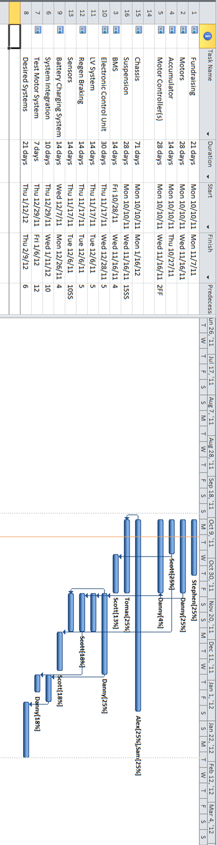

**7. Budget Estimate**

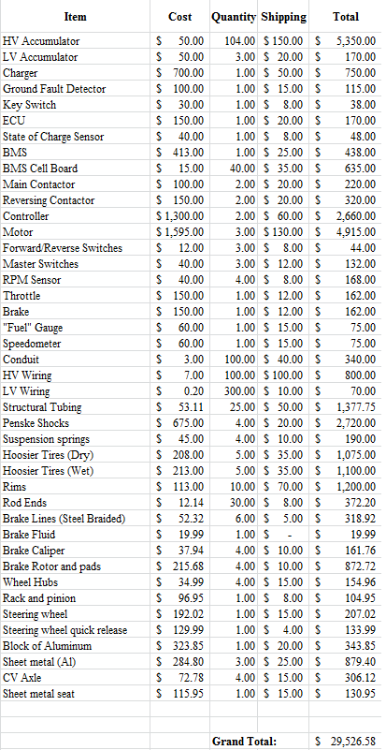

**8. Deliverables**

This year we will be creating an all electric formula style open wheeled car. This of course will be much smaller than the full sized formula cars of F1. The power train will be two electric motors connected to the rear differential, powered by multiple lithium ion battery packs. There is a possibility of front in wheel electric motors making the overall design an all wheel drive train configuration. Each wheel will have its own suspension components and will be tuned according to weight distribution and desired suspension characteristics. The braking system will affect every wheel and can bring the car to a stop in a safe distance.

Everything that is considered and implemented will be documented and presented in the senior design proposals. A report will be used to encompass all of the work on to a physical paper. This will include a set of dates and deadlines the team will follow to complete the project in a timely manner.

Considering this project is about designing a formula electric car and presenting the product to professional engineers, we will be going to the 2012 Formula Hybrid International Competition. In this competition we will be graded on the design of the car, as well as our ability to present information to the judges on how we implemented our designs into a real life vehicle. Safety specs will be rigorously tested and checked over. The goal will be to compete in the fully electric category and not only pass safety inspection the first time around, but to win in our division overall.

**References:**

"2012 Formula Hybrid™ Rules." Thayer School of Engineering at Dartmouth, 25 Aug. 2011. Web. 19 Oct. 2011. <http://formula-hybrid.org/pdf/Formula-Hybrid-2012-Rules.pdf>.

"Push-Pull Rod Suspension." Web. 16 Oct. 2011. <http://members.fortunecity.com/suspdesign/pushpull_rod_suspension.htm>.

**Appendix A**

**Accumulator Force Specifications**

* 20g static load in both the for/aft and side to side directions
* 8g static force in the vertical direction